Q1

--backup

--restore

Q2

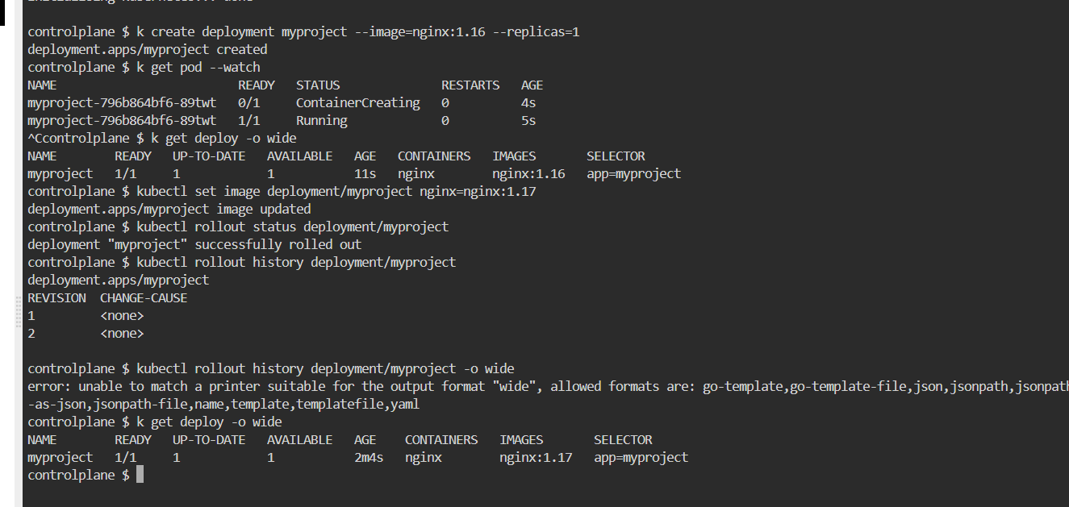

Q3



Q4

apiVersion: v1

kind: PersistentVolume

metadata:

name: app-data

spec:

capacity:

storage: 2Gi

volumeMode: Filesystem

accessModes:

- ReadOnlyMany

persistentVolumeReclaimPolicy: Recycle

storageClassName: ""

hostPath:

path: /srv/app-data

Q5

Q6

Q7

apiVersion: v1

kind: Pod

metadata:

name: nginx-kusc00401

spec:

containers:

- name: nginx

image: nginx

nodeSelector:

disk: ssd

Q8

--safari-pv.yaml

apiVersion: v1

kind: PersistentVolume

metadata:

name: safari-pv

spec:

capacity:

storage: 5Gi

volumeMode: Filesystem

accessModes:

- ReadWriteOnce

persistentVolumeReclaimPolicy: Recycle

storageClassName: ""

hostPath:

path: /volumes/data

-- safari-pvc.yaml

apiVersion: v1

kind: PersistentVolumeClaim

metadata:

name: safari-pvc

namespace: project-tiger

spec:

accessModes:

- ReadWriteOnce

volumeMode: Filesystem

resources:

requests:

storage: 5Gi

storageClassName: ""

--pod.yaml

apiVersion: v1

kind: Pod

metadata:

name: safari

namespace: project-tiger

spec:

containers:

- name: httpd

image: httpd:2.4.41-alpine

volumeMounts:

- mountPath: "tmp/safari-data"

name: mypd

volumes:

- name: mypd

persistentVolumeClaim:

claimName: safari-pvc

Q9

apiVersion: v1

kind: Pod

metadata:

name: kucc8

spec:

containers:

- name: nginx

image: nginx

ports:

- containerPort: 80

- name: redis

image: redis

ports:

- containerPort: 8080

Q10

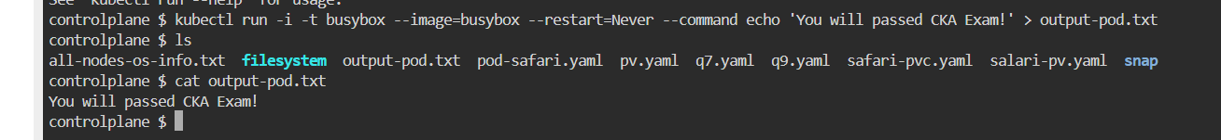

Q11

Q12

apiVersion: v1

kind: Pod

metadata:

name: mypod

spec:

containers:

- name: nginx

image: nginx

ports:

- containerPort: 80

- name: redis

image: redis

ports:

- containerPort: 8080

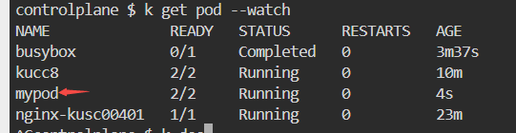

Q13

kubectl get pods --sort-by=.metadata.creationTimestamp

kubectl get pods --sort-by=.metadata.uid

Q14

Q15

apiVersion: v1

kind: Pod

metadata:

name: web-pod

spec:

containers:

- name: busybox

image: busybox

command: ['sh', '-c', 'sleep 3200']

securityContext:

capabilities:

add: ["SYS_TIME"]

Q17

Controlplane

Node01

* Only one node are ready (not tainted with noSchedule)

